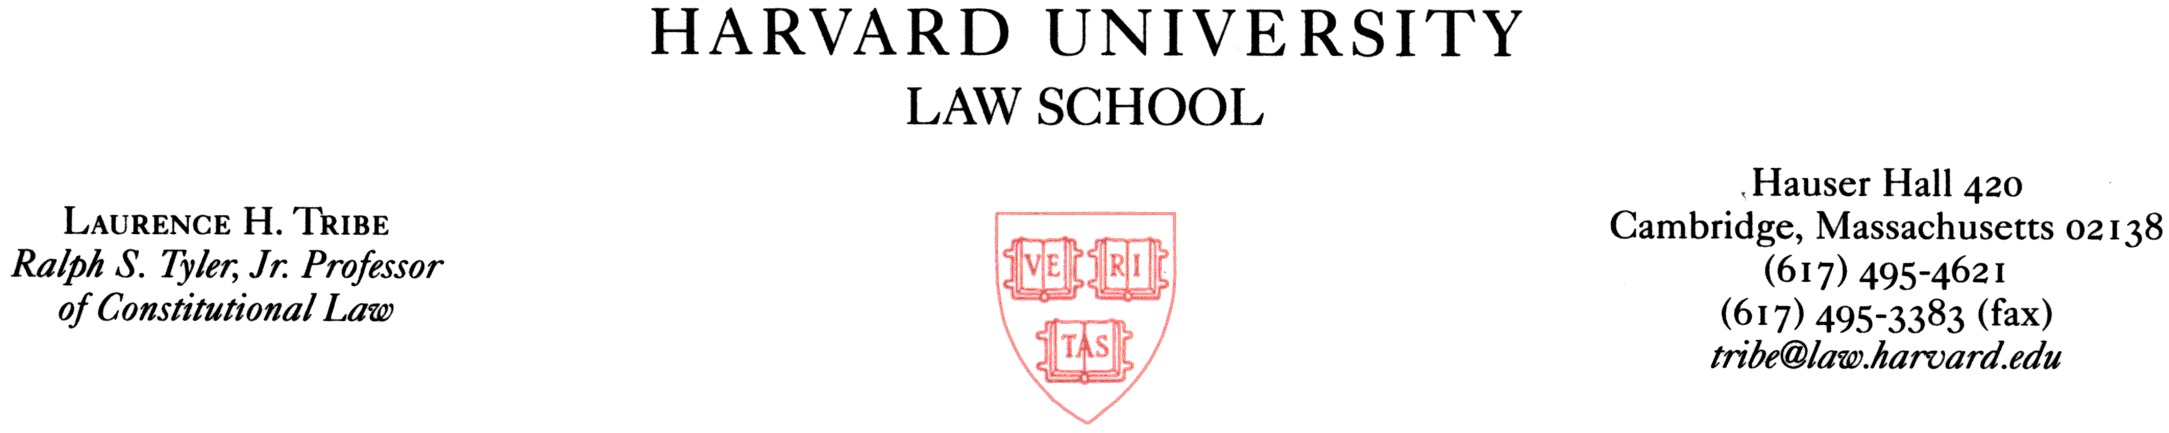

April 15, 2002

The Honorable Dianne Feinstein
United States Senate
SH-331 Hart Senate Office Building
Washington, DC 20510-0504

The Honorable Jon Kyl
United States Senate
SH-730 Hart Senate Office Building
Washington, DC 20510-0304

Dear Senators Feinstein and Kyl:

I think that you have done a splendid job at distilling the prior versions of the Victims’ Rights Amendment into a form that would be worthy of a constitutional amendment—an amendment to our most fundamental legal charter, which I agree ought never to be altered lightly. I will not repeat here the many reasons I have set forth in the past for believing that, despite the skepticism I have detected in some quarters both on the left and on the right, the time is past due for recognizing that the victims of violent crime, as well as those closest to victims who have succumbed to such violence, have a fundamental right to be considered, and heard when appropriate, in decisions and proceedings that profoundly affect their lives.

How best to protect that right without compromising either the fundamental rights of the accused or the important prerogatives of the prosecution is not always a simple matter, but I think your final working draft of April 13, 2002, resolves that problem in a thoughtful and sensitive way, improving in a number of respects on the earlier drafts that I have seen. Among other things, the greater brevity and clarity of this version makes it more fitting for inclusion in our basic law. That you achieved such conciseness while fully protecting defendants’ rights and accommodating the legitimate concerns that have been voiced about prosecutorial power and presidential authority is no mean feat. I happily congratulate you both on attaining it.

A case argued two weeks ago in the Supreme Judicial Court of Massachusetts, in which a woman was brutally raped a decade and a half ago but in which the man who was convicted and sentenced to a long prison term has yet to serve a single day of that sentence, helps make the point that the legal system does not do well by victims even in the many states that, on paper, are committed to the protection of victims’ rights. Despite the Massachusetts Victims’ Bill of Rights, solemnly enacted by the legislature to include an explicit right on the part of the victim to a “prompt disposition” of the case in which he or she was victimized, the Massachusetts Attorney General, to who has yet to take the simple step of seeking the incarceration of the convicted criminal pending his on-again, off-again motion for a new trial—a motion that has not been ruled on during the 15 years that this convicted rapist has been on the streets—has taken the position that the victim of the rape does not even have legal standing to appear in the courts of this state, through counsel, to challenge the state’s astonishing failure to put her rapist in prison to begin serving the term to which he was sentenced so long ago.

If this remarkable failure of justice represented a wild aberration, perpetrated by a state that had not incorporated the rights of victims into its laws, then it would prove little, standing alone, about the need to write into the United States Constitution a national commitment to the rights of victims. Sadly, however, the failure of justice of which I write here is far from aberrant. It represents but the visible tip of an enormous iceberg of indifference toward those whose rights ought finally to be given formal federal recognition.

I am grateful to you for fighting this fight. I only hope that many others can soon be stirred to join you in a cause that deserves the most widespread bipartisan support.

Sincerely yours,


Laurence H. Tribe

